Problem Set 4 ANSWERS

Due on Gradescope: check the course Drive calendar
Consult the Late Policy in the syllabus

Instructions: Work with this file as a template, perhaps by File: Download: Microsoft Word. Other options, like handwriting, are fine as long as they are legible. Name and SID at the top.

Did you work with other students? Identify them below. If you work with others, you should write answers in your own words. (If you understand your answers, this should be easy.)

Type your name to sign the Honor Code. Save as a PDF, upload to Gradescope, and click through to locate each question part before clicking Submit. Profit.

You will see point totals associated with each question. But we will score your problem sets based on completion, not correctness. The point totals are there to make you familiar with how the exams will work, which are scored on correctness.

Questions below:
1. [20 points total] Short answer questions
2. [20 points total] Saved by how the Government always asks about Investment
3. [40 points total] The Financial Crisis and the Short-Run Model

Did you work with other students? List them below:

Please type your name as an affirmation of the Honor Code at the University of California, Berkeley.

“As a member of the UC Berkeley community, I act with honesty, integrity, and respect for others.”

Type your name:

1. [20 points total] Short answer questions

- [2 points] Suppose that a nation engages in what becomes a protracted war overseas. But no military reservists are called up and away from their civilian jobs. What is the most obvious eﬀect on that nation’s GDP and why? (There’s no need to get fancy with your answer.)

Going to war probably raises defense spending, on increased pay for soldiers and sailors while serving in a combat zone, and on increased procurement of weapons and vehicles. Defense spending is part of G in Y= C + I + G + N X. Thus the most obvious eﬀect of a war is that it probably increases GDP at least in the short run.

- [3 points] What, if anything, is the danger posed by financing the war through government budget deficits? Explain. (There are multiple correct answers; just explain one.)

The danger is that government budget deficits, by reducing public saving, can reduce the funds available for private investment. We call this “crowding out.” You could also phrase this as government deficits raising total borrowing and debt and thus crowding out the capital stock. You could also argue that deficit-financed government spending is expansionary and thus inflationary unless the central bank raises interest rates. (If the government raised taxes instead, it might reduce consumption spending.) And there might be other logical arguments too.

Recall that almost all loans are written as nominal contracts, meaning that borrowers agree to pay lenders a specific amount or amounts of money in the future in exchange for a specific amount of money today. The nominal interest rate is the annualized rate of return implicit in the nominal contract.

- [3 points] Can the real interest rate ever be negative? If yes, under what circumstances? If no, why not?

Yes, the real interest rate can be negative.
Mathematically, as long as the nominal interest rate i is below the rate of inflation π, then the real interest rate R = i – π will be negative.
The real-world circumstances under which the real interest rate might be negative are a deep recession without deflation (π < 0). In a deep recession, the central bank will need to set its target real interest rate very low and perhaps negative in order to stimulate the economy. As long as deflation does not occur, very low nominal interest rates will produce negative real interest rates.

- [(3 points) Suppose inflation were to rise unexpectedly. In credit markets — think of banks and their customers — whom would this hurt, if anyone? Whom would this help, if anyone? Explain.

If inflation were unexpectedly higher than the level expected by borrowers and lenders, then inflation will erode the real value of debt repayments. That would help borrowers and hurt lenders. (Inflation also hurts consumers generally, unless their incomes are indexed to inflation. Does inflation hurt producers? I think it depends on whether they are net creditors or net borrowers; and to what extent there also is inflation in factor prices like wages and the returns to capital; and whether producers can raise their own prices in a timely manner.)

Politicians who like low inflation ($π$) typically also like a “strong dollar,” meaning that the dollar’s nominal exchange rate (E) is high, for example when the dollar ($) purchases many yen (¥) or euros (€).

- [4 points] State whether these two views are consistent or inconsistent with one another, and explain why. (There is a single correct answer, meaning either one or the other, but I think you could defend it at least two diﬀerent ways. State at least one explanation.)

These are consistent with one another.
In order to defend a high exchange rate and avoid a depreciation, central banks typically must raise interest rates in order to raise demand for their currencies by stimulating demand for assets denominated in their currencies. Raising interest rates usually reduces inflation through the Phillips curve.
Also, the Law of One Price implies a connection between the nominal exchange rate and inflation rates here vs. abroad: E = P^{w}/P where P^{w} is the foreign price level and P is the domestic U.S. price level. Keeping inflation low in the U.S. relative to what it is elsewhere means that g[E] = π^{w} – π > 0 and thus the dollar should appreciate and become stronger.

- [3 points] From the following list of constituencies (meaning political groups represented in the nation and in government), identify those that the “strong dollar” politicians probably represent, and briefly explain why.

- Exporters
- Consumers of imports
- Savers
- Borrowers
- Workers
- Retirees

A strong dollar hurts exporters but helps consumers of imports. To the extent that a strengthening dollar reflects slower inflation, a strong dollar also helps savers, who benefit from slower inflation, and hurts borrowers, who benefit from faster inflation. Retirees are likely to prefer a strong dollar and slower inflation, because they are net consumers and are living oﬀ savings, while workers should prefer a weaker dollar and faster inflation because they are producers and are probably saving rather than consuming on net.

2. [20 points total] Saved by how the Government always asks about Investment

Recall that national income accounting requires that

Y = C + I + G + EX – IM (2.1)

Total spending — consumption, investment, government, and net exports — sums to GDP, or national production, which is also equal to national income. Throughout this problem, it will help you to think of Y as income and fixed in the short run, even though in reality it is not.

- [3 points] Leave EX – IM on the right-hand side and subtract everything else except Y from both sides.

Y – C – I – G = EX – IM

- [3 points] On the left-hand side, add and subtract taxes, T. By bracketing with parentheses and labeling, show: (i) private saving, (ii) public or government saving, and (iii) investment.

Y – C – T + T – G – I = EX – IM

(Y – C – T) + (T – G) – I = EX – IM

Private saving + government saving – investment = net exports

Domestic saving – investment = net exports

Recall that in ECON 100B, we typically assume that total taxes T and income tax rates do not change working or consuming behavior. In other words, increases in taxes T directly reduces after-tax income, but we assume that higher tax rates do not change labor supply or income, and that they also do not change consumption. (For small changes, this is probably realistic.)

- [3 points] Under these assumptions, what are the eﬀects, if any, of an increase in taxes, T, according to your answer to part (b)? What about a reduction in taxes? Explain.

If consumption C and income Y are invariant to the level of taxes, T , then we can see from the answer to part (b) that any change in taxes will not change domestic saving. Taxes reduce private saving but increase public saving by an equal amount, leaving no eﬀect on the sum, which is national or domestic saving.

- [3 points] Make an argument for why the government should run a budget surplus by reducing G below T. Describe how that might increase a component of GDP, using equation (2.1) and your answer to part (b). (I can think of two; choose one.)

1. The most common argument is that when the government runs a budget surplus, public or government saving T – G rises, and that will raise investment I along with it if private saving and net exports remain unchanged.
2. You could also argue that rather than raising domestic investment, increased government saving could raise net exports or reduce the trade deficit. In this view, increasing government saving reduces the demand for foreign saving, and the trade deficit falls as a result.
(Astute students might point out that decreasing G to increase another expenditure component of GDP seems … weird, and not necessarily a net change in GDP. Although that is true, government spending also includes a lot of transfer payments, which still absorb funds from households but are not part of G.)

- [3 points] Now make a macroeconomic argument for why the government should run a budget deficit, by raising G above T. Describe how that could be good for GDP, using equation (2.1) and your answer to part (b) as need be.

This is a little more straightforward than the logic in the previous question. Government spending G is a direct addition to GDP, as shown in equation (2.1). Although the resulting budget deficit may crowd out investment, the first and most immediate eﬀect of an increase in G is a stimulus to spending that raises GDP.

Suppose I told you that research in macroeconomics suggests that when the government spends an additional ∆G = $1.00 on national defense, it appears that GDP actually rises on net by about ∆Y = $0.80 as a result. Why? Government spending partially crowds out other components of GDP, because it requires either higher taxes or higher borrowing or both.

- [5 points] Discuss this in light of your previous answers. Does this perspective suggest that one of the two arguments in parts (d) and (e) might be more wise? Explain fully.

When the government spending multiplier is 0.8, each dollar of government spending raises GDP by eighty cents. Twenty percent of the spending stimulus of ∆G gets oﬀset by reductions in some other component of GDP. Both perspectives in parts (d) and (e) might be correct, but one might be more wise than the other in the sense that the net eﬀect on GDP appears to be larger. Government spending raises GDP on net, but perhaps not fully one-for-one because some crowding out does occur. It might be better to cut taxes and stimulate investment or net exports.

3. [40 points total] The Financial Crisis and the Short-Run Model

In the second half of ECON 100B, we learn about the roles played by fiscal and monetary policy in promoting short-term macroeconomic stability, and we briefly discuss banks. How can we use the short-run model to understand the Financial Crisis of 2008 and the policy response?

Recall the standard IS, MP, and PC Curves we saw in class:
IS curve $\tilde{Y}=\bar{a}+\bar{b}(R-\bar{r})$ (3.1)
MP curve $R=R^{ff}+\bar{p}$ (3.2)
PC curve $Δπ=\bar{v} \tilde{Y}+\bar{o}$ (3.3)
where R is the real interest rate paid by borrowers; $\bar{r}$ is the marginal product of capital; $R^{ff}$ is the real federal funds rate, set by the U.S. central bank, the Federal Reserve (“Fed”); $\bar{p}$ is the risk premium charged by private lenders and paid by borrowers; $π$ is the inflation rate; $\bar{o}$ is an oil shock or other external inflation shock that can temporarily shift the Phillips Curve; and $\bar{a}$, $\bar{b}$, and $\bar{v}$ are all positive parameters.

- [4 points] Draw and label the IS-MP and PC Curves on the axes below.
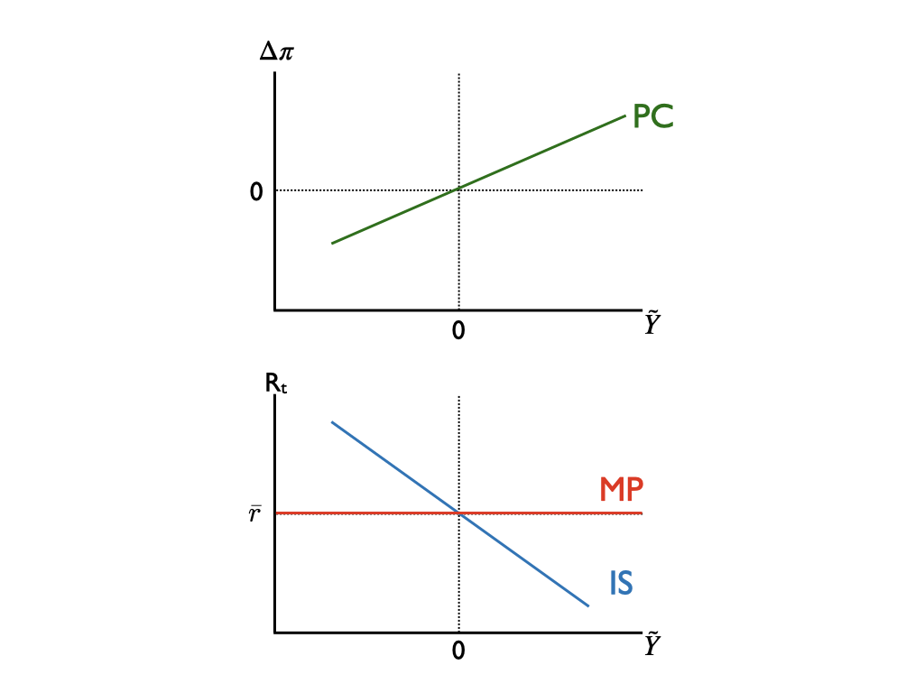
- [3 points] Look at equations (3.1), (3.2), and (3.3) and report which TWO elements in the short-run model dictate the eﬀectiveness of monetary policy in the short-run model. In other words: Suppose the Fed sees a big negative shock and lowers $R^{ff}$ by three percentage points, but there are two elements that determine the response of short-run output, $\tilde{Y}$. What are they? (Recall that the Fed cannot formally dictate borrowing terms in private markets.)

The risk premium, $\bar{p}$, and the slope of the IS Curve, $\bar{b}$, are the two elements that determine how $\tilde{Y}$ responds to a change in $R^{ff}$.
The risk premium $\bar{p}$ has the ability to fully oﬀset the eﬀects on the market interest rate R of any change in $R^{ff}$. For example, if the Fed cuts $R^{ff}$ but private lenders think that borrowers have become more risky, lenders will raise $\bar{p}$ potentially by more than the Fed cut $R^{ff}$.
The slope of the IS curve then determines how changes in the market real interest rate R translate into changes in short-run output $\tilde{Y}$. If $\bar{b}$ is large, the IS curve will be flat, and a change in R translates into a large change in $\tilde{Y}$. If $\bar{b}$ is small, R has little eﬀect on $\tilde{Y}$.

Consider the behavior of consumers before and after the crisis. Suppose that in normal times, consumers spend a portion $mpc$ of their excess current income in addition to the constant share ${\bar{a}}_{c}$ of their permanent income. Then the components of GDP behave like this:
Consumption $C/\bar{Y}={\bar{a}}_{c}+mpc ×\tilde{Y}$ (3.4)
Investment $I/\bar{Y}={\bar{a}}_{i}-\bar{b}(R-\bar{r})$ (3.5)
Government $G/\bar{Y}={\bar{a}}_{g}$ (3.6)
Net exports $NX/\bar{Y}={\bar{a}}_{nx}$ (3.7)
The next 5 questions step you through the process of deriving the IS curve under these conditions. Question (g) is the finish line, and you can jump to the end if you want, but for full credit, please show your work.

- [2 points] Write down the national income identity relating income Y to consumption and other elements of activity.

Y = C + I + G + NX

- [2 points] Divide both sides of your answer to part (c) by $\bar{Y}$.

$\frac{Y}{\bar{Y}}=\frac{C}{\bar{Y}}+\frac{I}{\bar{Y}}+\frac{G}{\bar{Y}}+\frac{NX}{\bar{Y}}$
- [2 points] Substitute equations (3.4)-(3.7) into your answer to part (d).

$\frac{Y}{\bar{Y}}={\bar{a}}_{c}+mpc ×\tilde{Y}+{\bar{a}}_{i}-\bar{b}(R-\bar{r})+{\bar{a}}_{g}+{\bar{a}}_{nx}$

- [2 points] Take your answer to part (e) and subtract 1 from both sides. On the left side, simplify. On the right side, define the sum of the $\bar{a}$’s and the 1 as a new $\bar{a}$ term, and rewrite in terms of $\bar{a}$, $mpc$, $\tilde{Y}$, and $\bar{b}(R-\bar{r})$.

$\frac{Y}{\bar{Y}}-1={\bar{a}}_{c}+mpc ×\tilde{Y}+{\bar{a}}_{i}-\bar{b}(R-\bar{r})+{\bar{a}}_{g}+{\bar{a}}_{nx}-1$
$\tilde{Y}={(\bar{a}}_{c}+{\bar{a}}_{i}+{\bar{a}}_{g}+{\bar{a}}_{nx}-1)-\bar{b}(R-\bar{r})+mpc ×\tilde{Y}$
$\tilde{Y}=\bar{a}-\bar{b}(R-\bar{r})+mpc ×\tilde{Y}$

- [2 points] Finally, combine terms containing $\tilde{Y}$ on one side and reveal the IS curve, showing $\tilde{Y}$ as a function only of R and parameters including $mpc$.

$\tilde{Y}=\bar{a}-\bar{b}(R-\bar{r})+mpc ×\tilde{Y}$
$\tilde{Y}-mpc ×\tilde{Y}=\bar{a}-\bar{b}(R-\bar{r})$
$(1-mpc) ×\tilde{Y}=\bar{a}-\bar{b}(R-\bar{r})$
$\tilde{Y}=\frac{1}{1-mpc}[\bar{a}-\bar{b}(R-\bar{r})]$

- [2 points) Has your answer to part (b) changed? Is there a third parameter that constrains the eﬀectiveness of monetary policy? If yes, what is it and why? If no, why not?

Yes, the answer has changed. Now the spender share $mpc$ also determines the eﬀectiveness of monetary policy. The higher $mpc$ is, the stronger are the eﬀects of monetary policy, because $1/(1-mpc)$ multiplies the entire IS curve.
(It is also the case that aggregate demand shocks through changes in $\bar{a}$ translate into larger shocks in $\tilde{Y}$, but the timing in this problem asserts that the demand shock happens first, and then the spender share $mpc$ falls afterward.)

The following graph shows time series plots of real income (Y ) and real consumption (C) over time between January 2007 and April 2010. Income is the top line and consumption is the bottom line.
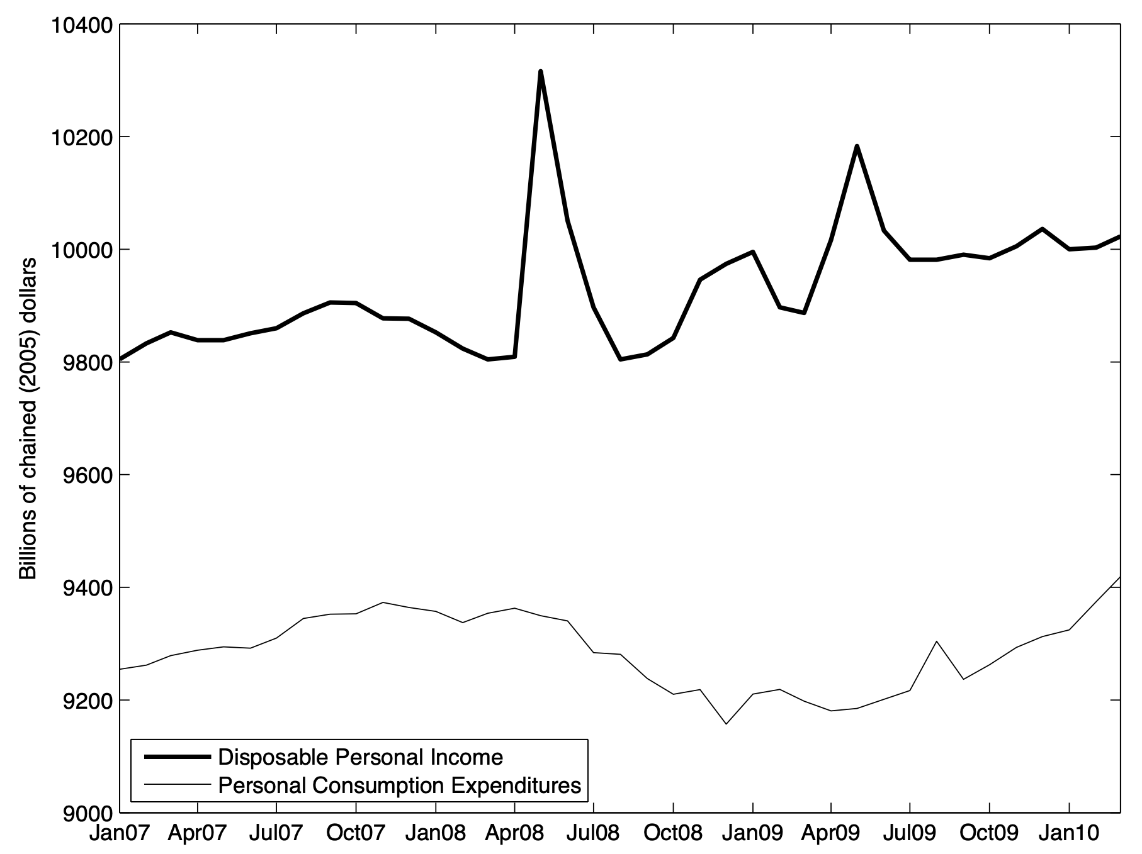

- [3 points] Normally, the “spender share” $mpc$, which is the proportion of temporary income fluctuations that are consumed, is probably around 30% or so. What seems to be true about the spender share here between January 2007 and January 2010? Give a rough estimate and explain.

Disposable personal income spiked in late spring 2008 with enhanced tax refund stimulus payments, and then again in spring 2009 with a smaller version of the same. Consumption barely budged. This graph suggests $mpc =0$, a real surprise.

- [3 points] Looking back at your answer to part (g), what, if anything, does your answer to part (i) imply about what has happened to the IS curve during the Financial Crisis? Explain. (Recall that in normal times, $mpc=0.3$ or so. Is that what you saw in part (i)?)

When the spender share $mpc$ falls from some positive number toward zero, the multiplier $1/(1-mpc)$ falls toward 1, and the IS curve becomes steeper. Monetary policy becomes less eﬀective.
- [3 points] Changing gears: If some event prompts financial markets to perceive greater risk than they previously saw, what happens to $\bar{p}$ and thus R given any level of $R^{ff}$ ?
When markets perceive more risk, private lenders will charge a larger risk premium $\bar{p}$ on loans than they previously had. Thus $\bar{p}$ will rise because of an increased risk premium, and it will pull the MP curve higher.

- [12 points] Use the axes below to produce a diagram showing the financial crisis, and in the space provided, narrate appropriately. Assume the financial crisis consists of these events, in order:
  - There is a massive fall in ${\bar{a}}_{c}=C/\bar{Y}$ as consumers reduce their spending share of potential GDP because they find their housing assets are worth far less than previously thought;
  - Consumers also change their behavior as you described in parts (i) and (j);
  - The Fed takes action to counteract these events; but
  - Financial markets behave as laid out in part (k)
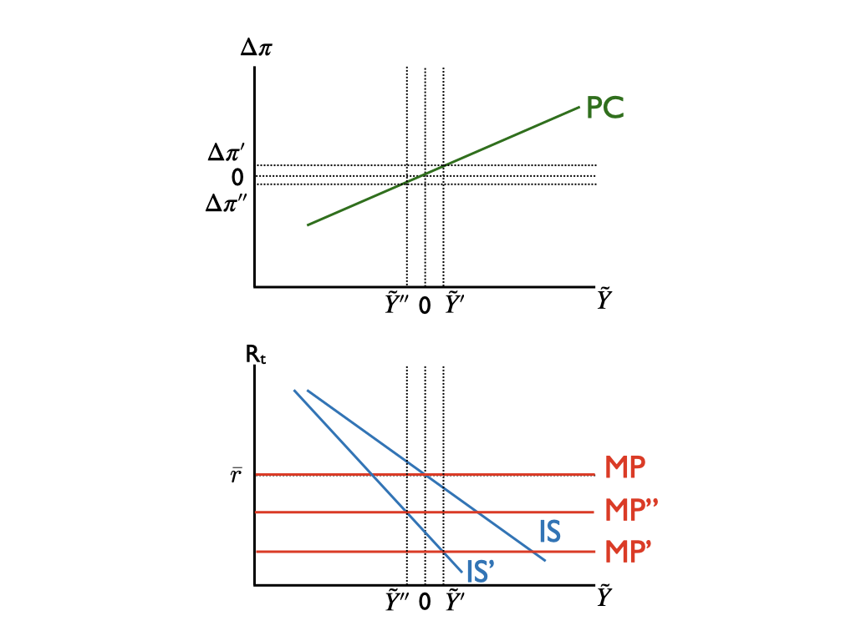

These graphs can appear in a variety of ways and still be correct, but what is shown here is probably a good baseline. The main points are that

- The Phillips Curve never shifts
- The economy begins at the short-run equilibrium, with the original (blue) IS and MP curves
- The demand shock in part shifts the IS curve leftward, and consumers restrict their spending share in part, which also steepens the IS curve to the solid green IS’
- Monetary policy reacts and shifts the MP curve down to MP’
- But financial markets in part (iv) raise the risk premium and push MP’ up to MP”

I have drawn the picture so that at the end of the day, the economy is still in recession at $\tilde{Y}''<0$ with inflation falling $Δπ''<0$. The intersection of IS’ and the Fed’s intended policy at MP’ is at $\tilde{Y}'>0$, meaning a spot where there is a boom and inflation is rising.

Valerie A. Ramey (2011) “Identifying Government Spending Shocks: It’s All in the Timing,” Quarterly Journal of Economics 126(1): 1–50.

